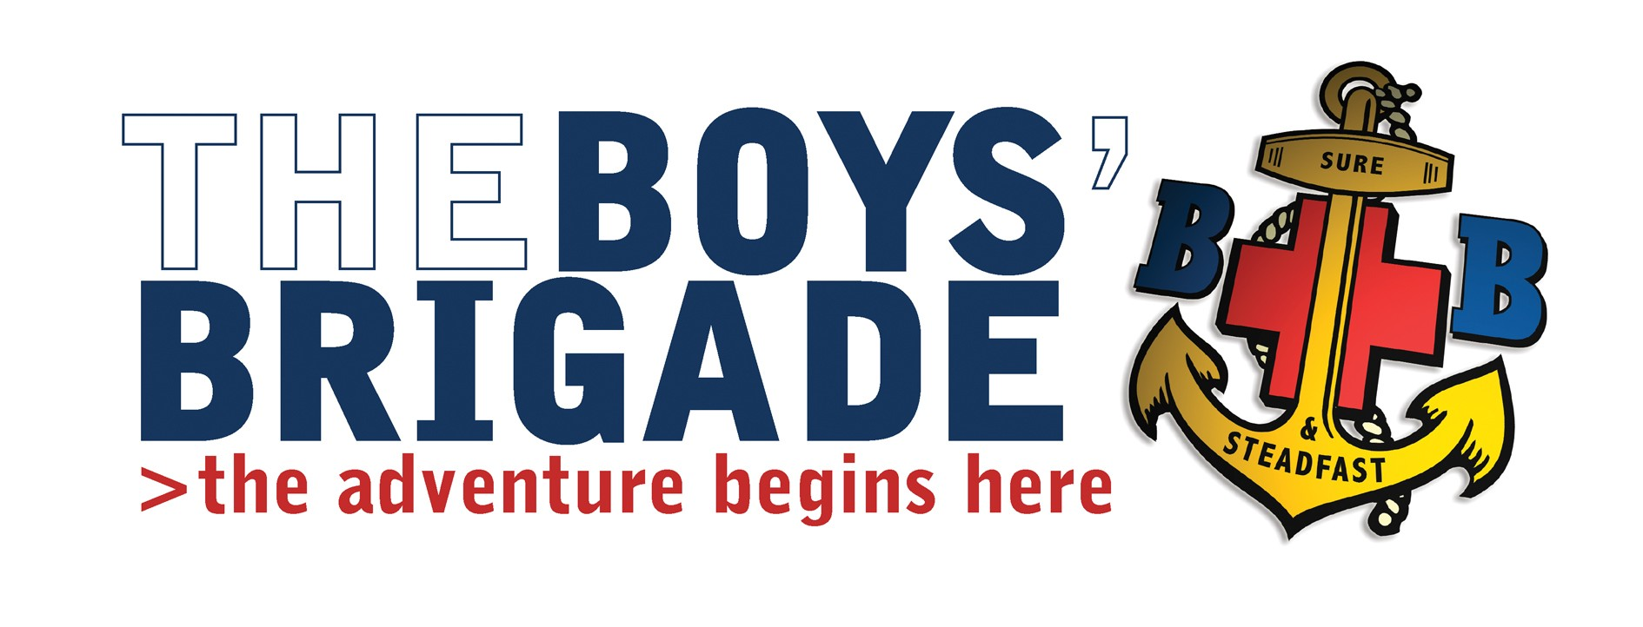
Sept 2017

Holiday Leadership Course – Sunday 15th October 2017
Venue; Boys Brigade, Leng House, Heathfield, Pateley Bridge, HG3 5.P.U. North Yorkshire.
Course Timings; Sunday 15th October 10.00am – 4.30pm.
Cost; £5.00 per person.
Dear Captain
The Leeds Battalion is running the above course, This one-day course will equip BB leaders with the skills, knowledge and understanding to plan and lead holiday activities for children and young people.
The course will help participants to: - Identify the key elements in the preparation phase of a holiday, including BB regulations and child protection procedures. Set realistic aims for the event in consultation with young people. Carry out effective risk assessments for holidays. Identify the key steps to ensure good food hygiene. Understand and meet the needs of children and young people away from home. Contribute to positive working relationships with adult colleagues. Understand what underlies disagreements and conflict.
The candidate must be an Officer or Warrant Officer who has completed Youth Leader Training, the course will include a buffet lunch.
If any of your staff are interested please let me know by as soon as possible and I will send out a booking form/s.
Yours Sincerely
T Goddard

Tim Goddard
Battalion Training Convenor

