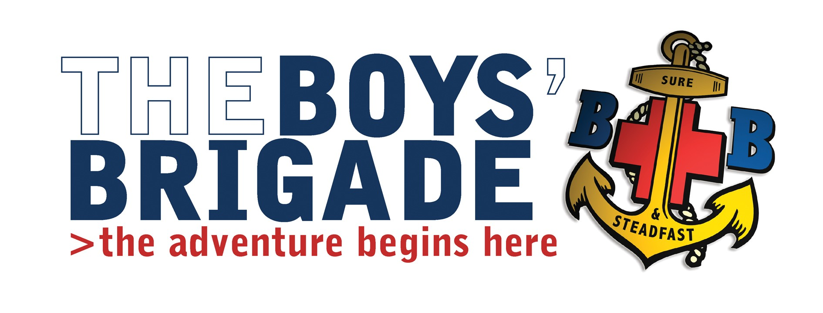
Sept 2017

Camp Craft Course – Sunday 15th October 2017

Venue; Boys Brigade, Leng House, Heathfield, Pateley Bridge, HG3 5.P.U. North Yorkshire.
Course Timings; Sunday 15th October 10.00am – 4.30pm.
Cost; £5.00 per person.

Dear Captain
The Leeds Battalion is running the above course, the aim is to equip BB Leaders with the skills, knowledge and understanding to prepare and run a successful canvas camp, the course will include a buffet lunch.

If any of your staff are interested please let me know by as soon as possible and I will send out a booking form/s.
Yours Sincerely
T Goddard

Tim Goddard
Battalion Training Convenor

