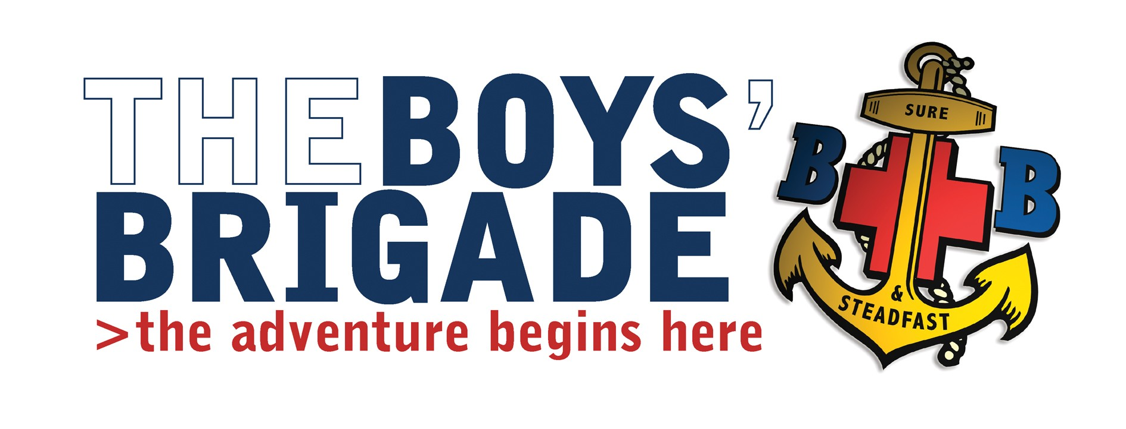
Sept 2017

Building Your Skills Course – Saturday 14th October 2017

Venue; The Boys Brigade “Leng House” Heathfield, Pateley Bridge, North Yorkshire HG3 5.P.U.
Course Timings; Saturday 14th October 2017, 10am - 4.30pm
Cost; £5.00 per person.

Dear Company Captain

I invite young People from your company to attend this event.
Building your Skills is the course, which has re-placed the Leadership Grade 3. It is a requirement to attend this course as part of the qualification towards the Presidents Badge.
Buffet lunch will be provided
If any of your young people would like to attend please let me know by phone or e-mail by 1st October 2017.
Yours Sincerely

TJ Goddard

Tim Goddard
Battalion Training Convenor

