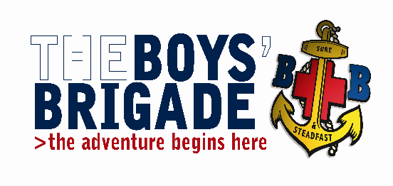
THE BOYS’ BRIGADE GRIMSBY & DISTRICT BATTALION.
Training Convenor: Iain Betts
30 Pretymen Crescent, Grimsby, N.E. Lincolnshire. DN36 4NS
Tel: 07850 139999 e-mail: gyanddistbbtraining@gmail.com

January 2019

Youth Leader Training Course (including Safeguarding)
Venue: St Giles Methodist Church, Addison Drive, Lincoln LN2 4LQ
Dates: YLT Part 1: May 11 2019 - YLT Part 2: June 15 2019 Times: 09:00 – 17:45
Safeguarding only: May 11 2019 (Morning session including lunch)
Dear Colleagues
The Grimsby and District Battalion are running a Youth Leader Training Course which will take place over two Saturdays 11th May 2019 and 15th June 2019 at St Giles Methodist Church, Addison Drive, Lincoln LN2 4LQ. Attendance on both Saturdays will be required to complete the training.
- Youth Leader Training is the core training for anyone who wishes to become an officer / leader in The Boys' Brigade.
- This course is open to current Officers and Leaders who wish to refresh and or update their existing skills and knowledge.
- It is also open to other leaders / helpers who wish to extend their skills and knowledge in working with children and young people but who may not wish to become officers.
- Prior to being appointed as a Lieutenant leader are required to have satisfactorily completed a Youth Leader Training course.
- Warrant Officers should complete Youth Leader Training by the end of the first complete session after registration
This course covers the essential core modules for both under 11’s and over 11’s plus additional programme modules.

- For those leaders who only require the Safeguarding and Child Protection modules, this can be achieved by attending the morning sessions on Saturday 11th May 2019.
Candidates wishing to attend any of the above training are asked to complete the appropriate accompanying booking and candidate information forms, then return them to Mr Iain Betts at the above address.
The closing date for bookings is Saturday 20th April 2019. (All candidates under the age of 18 will be required to bring a special Activities Consent form with them on the training days.)
The cost for the full YLT course including safeguarding is £10.00 per candidate, including lunch.
The cost of the Safeguarding and Child Protection module only is £5.00 per candidate including lunch.
Cheques should be made payable to Grimsby and District Battalion.
If you have any questions or issues regarding this training, please do not hesitate to contact Mr Iain Betts.

Yours in BB fellowship,
Iain Betts
Grimsby & District Battalion Training Convenor

