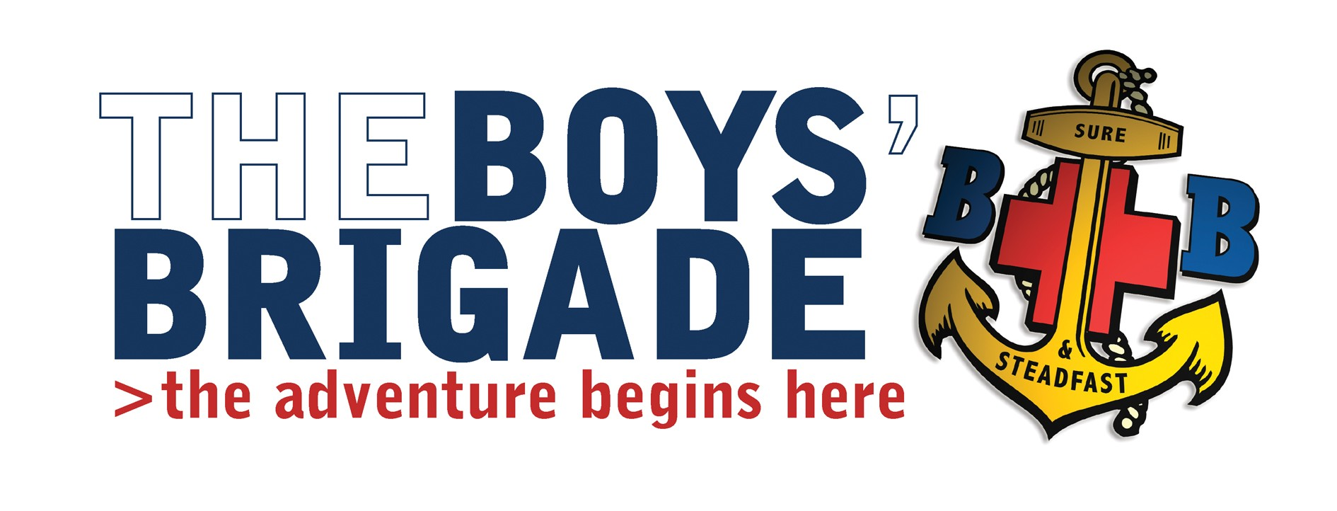
Sept 2017

Queens Badge, Skills based Training – Saturday 14th October 2017

Venue; The Boys Brigade “Leng House” Heathfield, Pateley Bridge, North Yorkshire HG3 5.P.U.
Course Timings; Saturday 14th October 2017, 10am - 4.00pm
Cost; £5.00 per person.

Dear Company Captain

On behalf of the Queens Badge Advisor I invite your People that are working toward the Queens Badge from your company to attend this event.
The aim of the course is to equip Queen’s Badge participants with the skills and knowledge to work safely and effectively with children in a BB company.

Buffet Lunch will be provided.

If any of your young people would like to attend please let me know by phone or e-mail by 1st October 2017.
Yours Sincerely
TJ Goddard

Tim Goddard
Battalion Training Convenor

