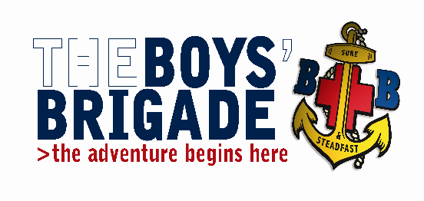
THE BOYS’ BRIGADE GRIMSBY & DISTRICT BATTALION.
Training Convenor: Iain Betts
30 Pretyman Crescent, Grimsby, N.E. Lincolnshire. DN36 4NS
Tel: 07850 139999 e-mail: gyanddistbbtraining@gmail.com

Fao: Company Captains / Leaders in Charge
Building Your Skills Course
Venue: St Giles Methodist Church, Addison Drive, Lincoln LN2 4LY
Date: Saturday 27 April 2019 Time: 10:00 – 16:00
The Grimsby and District Battalion are running a Building Your Skills course (formerly Grade 3 Leadership) which will take place on Saturday 27th April 2019 at St Giles Methodist Church, Addison Drive, Lincoln LN2 4LY.
This course is for those young people usually in school year 10 or above who are working towards completing the President's Badge mandatory requirements. The course is largely practically based and will encourage young people to work as a team. Activities will include role-plays, simulation games and discussions.
If you have any candidates wishing to attend, I would be grateful if you would return the accompanying booking form to me as soon as possible. The closing date for bookings is Saturday 6th April 2019.
All participants will be required to bring a completed special activity consent form with them, anyone failing to do so will be not be allowed to participate in the training course.
The cost of the course is £5.00 per candidate, which includes lunch. Cheques should be made payable to Grimsby and District Battalion.

Yours in BB fellowship,
Iain Betts
Grimsby & District Battalion

