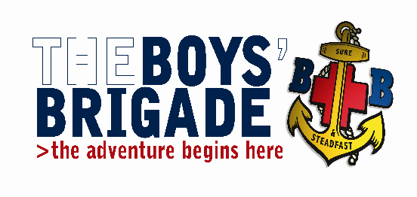
THE BOYS’ BRIGADE GRIMSBY & DISTRICT BATTALION.
Training Convenor: Iain Betts
30 Pretymen Crescent, Grimsby, N.E. Lincolnshire. DN36 4NS
Tel: 07850 139999 e-mail: 7th.grimsbybb@gmail.com

September 2020

Holiday Leadership Training Course
Venue: St Giles Methodist Church, Addison Drive, Lincoln LN2 4LY
Date: 21st March 2020 Time: 09:30 – 17:00
Dear Colleagues
The Grimsby and District Battalion are running a Holiday Leadership training course which will take place on Saturday 21st March 2020 at St Giles Methodist Church, Addison Drive, Lincoln LN2 4LY.
This course should to be taken at some point after Youth Leader Training, successful completion of this course is essential to achieve the Holiday Leadership Certificate which is a requirement for all Officers leading a camp or holiday including sleepovers at your own company premises with a duration of one or more overnights .
The holiday leadership certificate lasts for a period of 5 years and is kept live by completing log sheets and having undertaken at least one holiday during the 5 years.
Candidates wishing to attend are asked to return the accompanying booking form to me either via conventional post or e-mail as soon as possible. The closing date for bookings is Saturday 29th February 2020.
The cost of the course is £5.00 per candidate, which includes lunch. Cheques should be made payable to Grimsby and District Battalion.

Yours in BB fellowship,
Iain Betts
Grimsby & District Battalion

