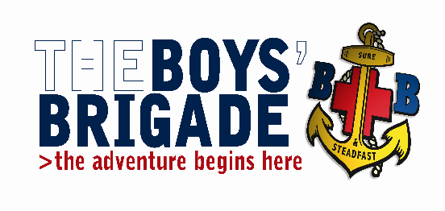
THE BOYS’ BRIGADE GRIMSBY & DISTRICT BATTALION.
Training Convenor: Iain Betts
30 Pretymen Crescent, Grimsby, N.E. Lincolnshire. DN36 4NS
Tel: 07850 139999 e-mail: gyanddistbbtraining@gmail,com

September 2020

Captains / Officer in-charge Training Course
Venue: St Giles Methodist Church, Addison Drive, Lincoln LN2 4LY
Date: 15 February 2020 Time: 09:30 – 17:00
Dear Colleagues
The Grimsby and District Battalion are running a Captains / Officer in-charge training course which will take place on Saturday 15 February 2020 at St Giles Methodist Church, Addison Drive, Lincoln LN2 4LY.
This course should to be taken at some point after Youth Leader Training by experienced leaders, and is open to existing Captains, prospective Captains, Officers in Charge of Sections and Officers who take an active role in the management of a company.
This course covers the essential information and skills for Captains and Officers-in-Charge.
Candidates wishing to attend are asked to return the accompanying booking form to me either via conventional post or e-mail as soon as possible. The closing date for bookings is Saturday 25th January 2020
The cost of the course is £5.00 per candidate, which includes lunch. Cheques should be made payable to Grimsby and District Battalion.

Yours in BB fellowship,
Iain Betts
Grimsby & District Battalion Training Convenor

