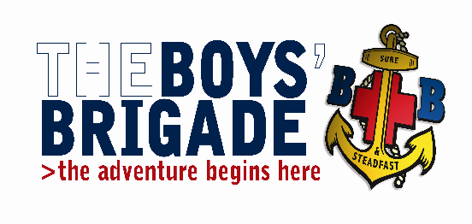 **THE BOYS’ BRIGADE GRIMSBY & DISTRICT BATTALION**.

Training Convenor: Iain Betts

30 Pretyman Crescent, Grimsby, N.E. Lincolnshire. DN36 4NS

Tel: 07850 139999 e-mail: [gyanddistbbtraining@gmail.com](mailto:gyanddistbbtraining@gmail.com)

June 2019

Fao: Company Captains / Leaders in Charge

**Skills for Queens Badge**

**Venue:** St Giles Methodist Church, Addison Drive, Lincoln LN2 4LQ

**Date:** Saturday 12 October 2019 **Time:** 09:15 – 17:00

The Grimsby and District Battalion are running Skills for Queens Badge course (formerly Brigade Leadership) which will take place on Saturday 12th October 2019 at St Giles Methodist Church, Addison Drive, Lincoln LN2 4LY.

This is a practical course focusing on the development of new and existing skills for those young people who have gained their Presidents Badge and are now working towards their Queens Badge. The course has been designed to help prepare and support candidates in an element of their Queen's Badge programme.

On confirmation of booking candidates will be sent out the course information which will include details of the pre course preparation required and a blank special activity form.

If you have any eligible Queens Badge candidates who wish to attend this training course, I would be grateful if you would return the accompanying booking form to me as soon as possible. The closing date for bookings is Saturday 21st September 2019.

**All participants will be required to bring a completed special activity consent form with them, anyone failing to do so will be not be allowed to participate in the training course.**

The cost of the course is £5.00 per candidate, which includes lunch. Cheques should be made payable to The Boys Brigade Grimsby and District Battalion

Yours in BB fellowship,

Iain Betts

Grimsby & District Battalion Training Convenor